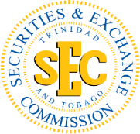

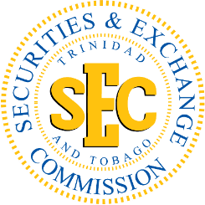
PUBLIC ADVISORY
“Quick Promo”

The Trinidad and Tobago Securities and Exchange Commission (TTSEC) alerts the public that an entity operating under the name “Quick Promo” is NOT registered with the Commission and is NOT authorised to conduct securities or investment-related business in Trinidad and Tobago.
Members of the public are urged to exercise caution and conduct due diligence when evaluating the legitimacy of any person or entity before making an investment. The following red flags should be carefully considered when assessing the legitimacy of any investment opportunity:
- Emphasis on recruiting others to join the venture;
- Compensation is based on the number of persons recruited;
- Promises of easy money in a short period of time;
- Fees required to withdraw or access earnings;
- Delays in processing withdrawals; and
- Registration or entrance fees required to participate.
If an opportunity seems “too good to be true,” it likely is. Always verify before you invest.
For further information or to report a scam, please contact the TTSEC using any one of the following options:
- Email: marketcomplaints@ttsec.org.tt
- Complaint Form: https://www.ttsec.org.tt/complaint-form/
- Hotline: 1-868-223-2991 (Option 4)
A list of businesses and individuals currently registered under the Securities Act Chapter 83:02 to undertake securities business in Trinidad and Tobago can be found at List of Registered and/or Authorized Companies and Individuals - TTSEC | You Invest. We protect. Everyone Benefits!
Stay alert. Stay safe. Protect your money.

Dated: November 6, 2026
PUBLIC ADVISORY

